How to play my game:

1. Download the Unity Folder labeled “ASL Game copy.zip” and unzip it
2. Run the unzipped files in Unity
3. Play the game!\*

*\*The game is prone to crashing, especially on the webcam pages, just restart it and try not to spend too long on each page!*

*\*\* You will also find the .onnx file version of the trained AI model in this folder (“asl1000.onnx”). This is for your reference as I used the .onnx version to import the model into Unity.*

How to run the trained AI model I made:

1. Download the PyTorch file in this folder labeled “asl1000.pt”
2. Run the PyTorch file by accessing it through terminal 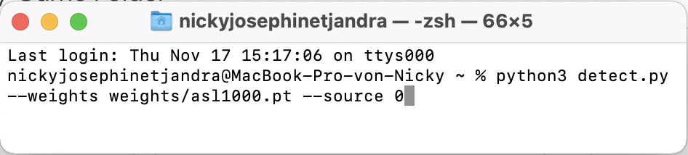
3. A python window with a webcam should pop up as below 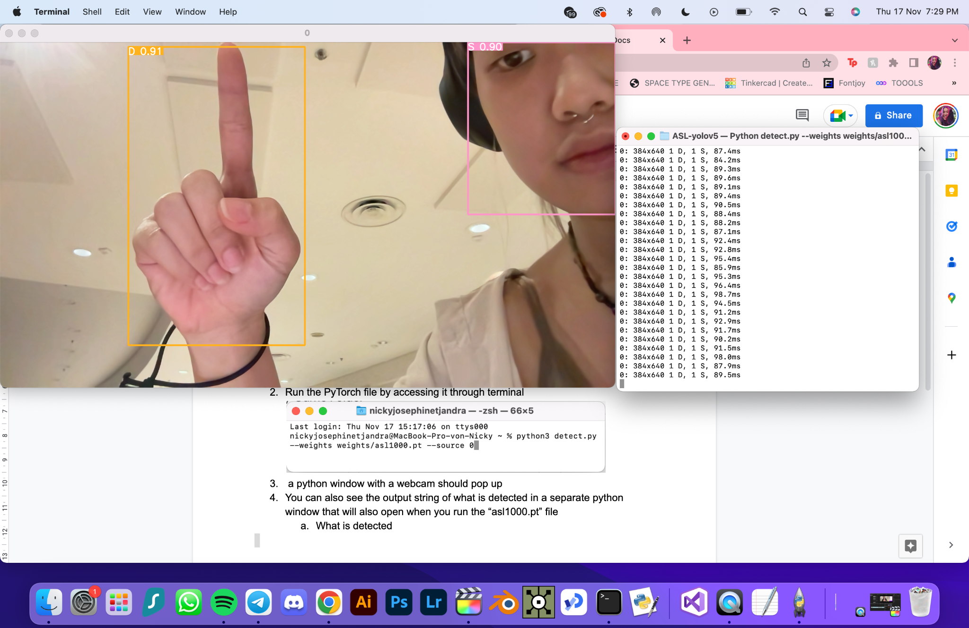
4. You should also see the output string of what is detected in a separate window that will also open when you run the “asl1000.pt” file
   1. When there is no detection, the out will show “(no detection)”
   2. When there is a detection, the output will show the letter(s) that are being detected

